

GospelPreaching.com
Planning Report

Table of Contents
Background 3
Project Leader 3
Company Information 3
System Name and Description 3
System Stakeholders 3
Existing System 4
Figure 1 – Current system – Home page 5
Figure 2 – Current system – Article index 5
Figure 3 – Current system – Audio recording index 6
Figure 4 – Current system – Single article view 6
Figure 5 – Current system – Tract view 7
Technology 7
Figure 6 – Implemented Use Case: View Article – Article Details 8
Figure 7 – Implemented Use Case: View Article – Article Index 9
Figure 8 – Implemented Use Case: View Article – Database screenshot 10
Initial Requirements Assumptions 10
Development Methodology 12
Ultimate Project Disposition 12
System Benefits 12
Tangible Benefits 12
Intangible Benefits 12
Project Schedule and Costs 13
Phases, Activities, Tasks, and Person Hours 13
Project Costs 16
Feasibility Study 16
Organizational and Cultural Feasibility 16
Evaluating the Technological Feasibility 16
Determining the Schedule Feasibility 17
Assessing the Resource Feasibility 17
Determining the Economic Feasibility 17
Summary 17
Project Monitoring/Reporting To Date 18
Appendix A: Code Excerpts 20
models.py 20
urls.py 22
views.py 22
base.html 23
index.html 24
detail.html 25
Legal Notes 27
Other Notes 27

Background

Project Leader
David Nichols
417.847.7596
Nichols316@live.missouristate.edu

Company Information
Contending for the Faith Publications
Allen Bailey, Owner
4216 Abigale Drive
Yukon, OK 73099
214.505.8242
allen.bailey@yahoo.com

CFTF Publications is a small publisher of religious books, tracts, and other media related to the Church of Christ. Allen Bailey is the owner/operator. Writers or extra editors are hired or volunteer on an as-needed basis. The company's main goal is to spread the Gospel and edify existing Christians through the publishing/availability of religious materials. CFTF doesn't have any physical publishing facilities.

System Name and Description
The system is going to be an online portal for CFTF's electronic resources (documents, audio, video, etc.) and a storefront for the company's published goods. The system will simply be known as “GospelPreaching.com”. Along with the system's basic functions mentioned above, it will also provide the ability to categorize and tag electronic materials, post and respond to questions (Q&A), allow users to connect their profiles with social networking sites (Facebook, Twitter, etc.), post comments, and “like” (favorite) articles.

System Stakeholders
Allen Bailey would be the principle user of the site, performing administrative functions in the system. Other users would include the site visitors would be viewing the electronic resources, purchasing published goods, and utilizing the social aspects of the site. There is also the possibility of hiring or finding volunteers to perform the conversion of materials to electronic format. These people would need to have the ability to upload new materials to the site.

Existing System
The current system is a simple static site with a little basic PHP. The current site is only serving as a placeholder for the proposed system and is not adequate for continued use as it lacks many key features CFTF is looking for. Please refer to the figures below and the following list for more details about what some of the shortcomings of the existing system are, as was discussed during informal stakeholder interviews.

Problems with old system:
- It requires someone to have a working knowledge of PHP and HTML to add material to the site.
- It lacks any social or interactive elements for visitors.
- No capabilities to sell books and tracts.
- Very low administrator usability.
- Electronic resources are simply displayed as a list of titles, needs to be displayed in a more logical and visually appealing way. (Figures 2, 3)
- No search function.
- Home page isn't very functional. Doesn't display recent articles, announcements, etc. (Figure 1)
- Doesn't display combined content (text, audio, video, etc.) on one detail page very effectively, or attractively. (Figures 4, 5)

Opportunities:
- Non-technical administrators could upload and manage resources by themselves.
- Provide the opportunity for users to interact socially, helping promote thoughtful discussions and generate interest in materials.
- Introduces the ability to sell the firms publications to a much larger market.
- The site will also be more usable and inviting for readers.


Figure 1 – Current system – Home page

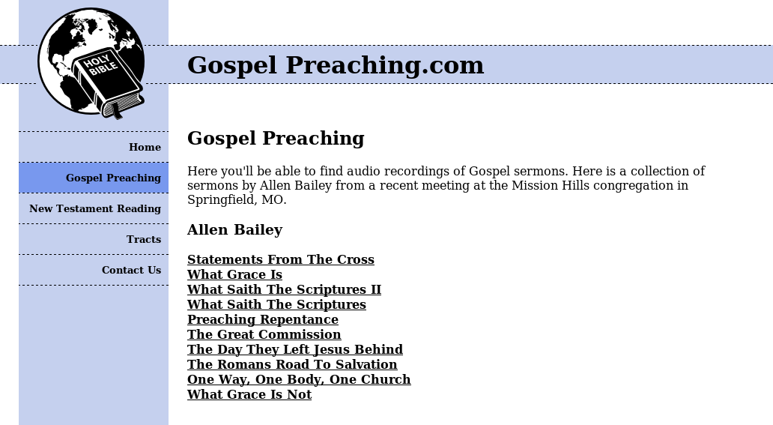
Figure 2 – Current system – Article index

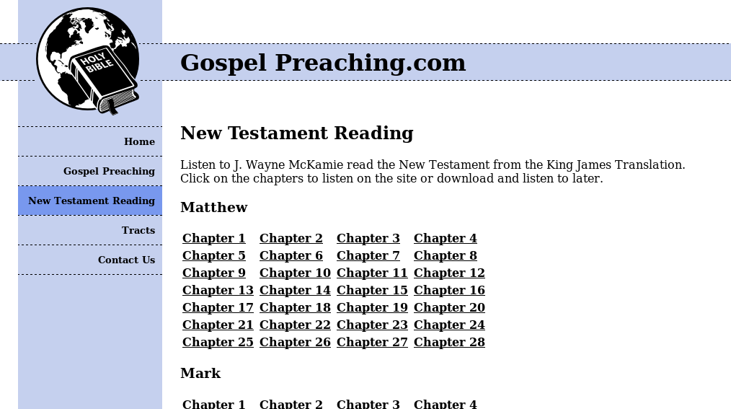
Figure 3 – Current system – Audio recording index

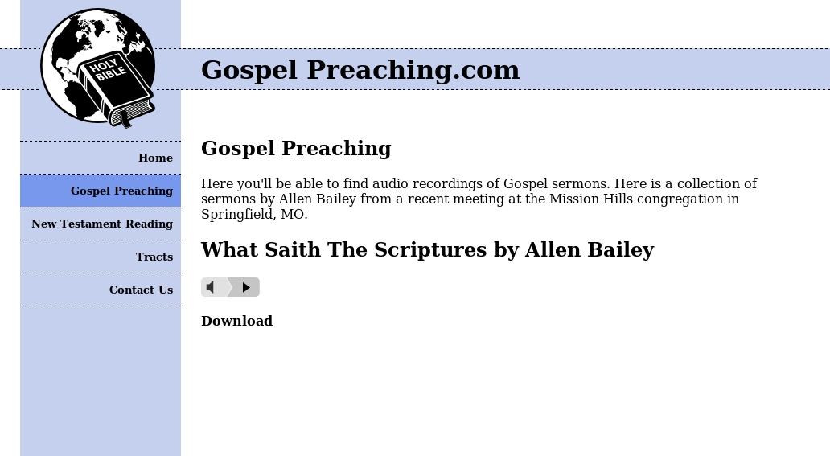
Figure 4 – Current system – Single article view

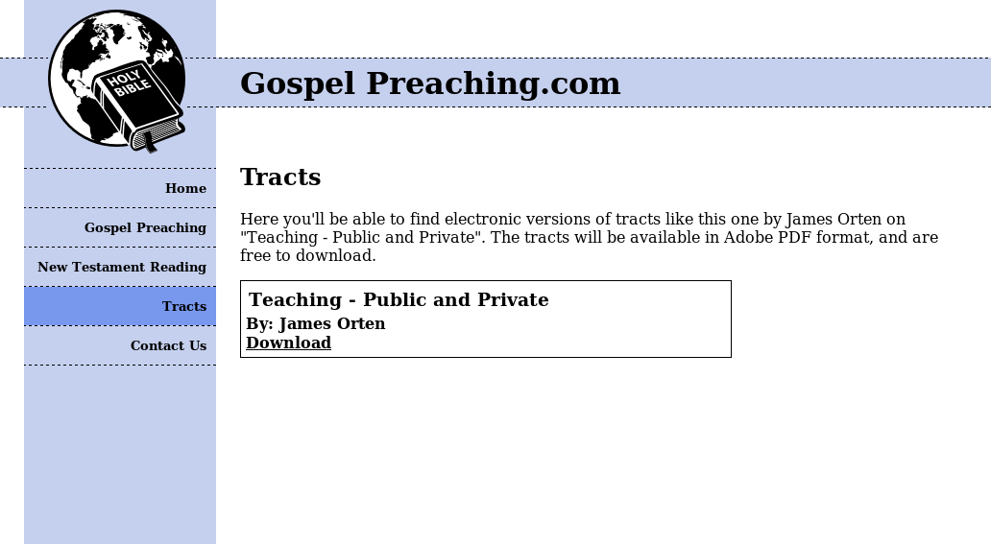
Figure 5 – Current system – Tract view

Technology
The system would use the Django framework for Python. MySQL would be used for the database and the whole system would run on the existing LAMP server stack. Design should adhere to a strict object-oriented, three layer web design.

There are currently no other systems in the organization to integrate with.

The only work that has been completed beforehand is some proof of concept code to test the viability of the framework and the existing HTML and CSS of the old system.

I've used this framework for other client sites in the past and feel comfortable using it for this project. Django is an open-source platform and has a very extensive community including a thorough documentation and tutorial wiki on the project's website. I also know several developers who have a considerable working knowledge of the framework. Therefore, I don't expect to have any difficulties obtaining support if needed.

The use case I used to test the framework and design approach I'll be using is “View Article”. This use case involves both an index to find the article you're looking for, as well as a details page to view the full article. Please refer to figures 6 and 7 below to see the screenshots of the implemented use case.

Please reference Appendix A when reading the following description of the code. The Django code is structured a little bit different than a typical MVC design. It's still implemented using a three layer design though. The models, or data access takes place in models.py. No SQL strings are ever directly manipulated by user created code; the Django framework handles all of that. I simply defined the structure of the classes and all the SQL string conversion will be taken care of automatically based on the connection settings in the main settings.py file. The controller code is mostly handled by the framework. However, there are configuration settings that manage the functionality of the controller code. The most notable of these is the urls.py file which defines which view to display. According to the Django's interpretation of MVC, the views.py file manages the view layer. This interpretation defines the view layer as making the decision of what to display, instead of how to display it. This logic would traditionally be found in the controller layer in other MVC frameworks. The final piece of the puzzle is the template system. The templates define how the information is to be displayed, and consist of HTML files with template tags. You can look at base.html, index.html, and detail.html for the relevant templates in this use case.

Please refer to figure 8 for a screenshot of the database table used in this use case.

I'd like to add one note to this use case. The code uses separate classes for different types of media instead of having a single media class. I did this to try a different approach and see how it would work. This detail will be decided in the next iteration and be reflected the analysis report.

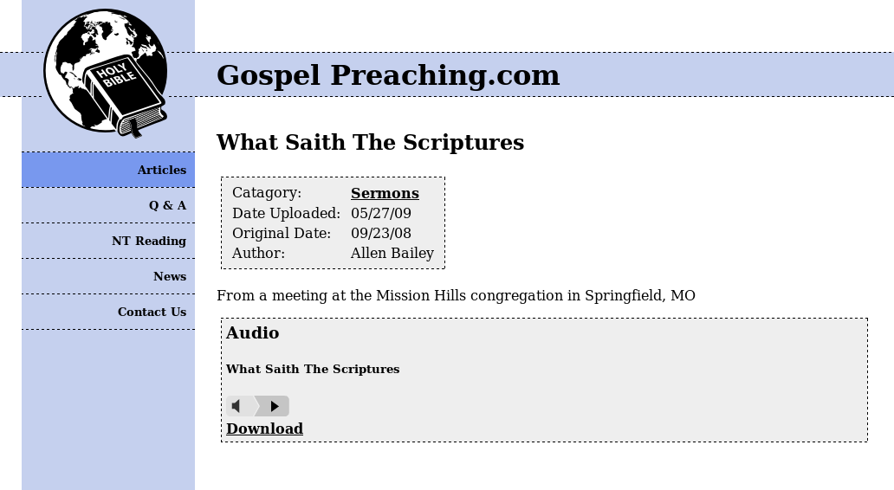
Figure 6 – Implemented Use Case: View Article – Article Details

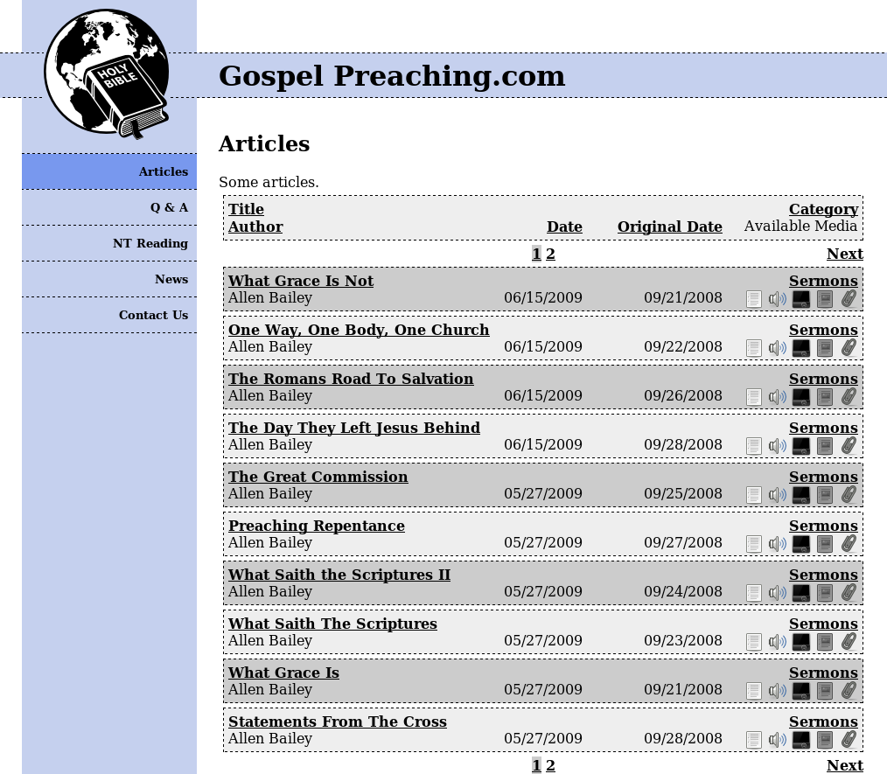
Figure 7 – Implemented Use Case: View Article – Article Index

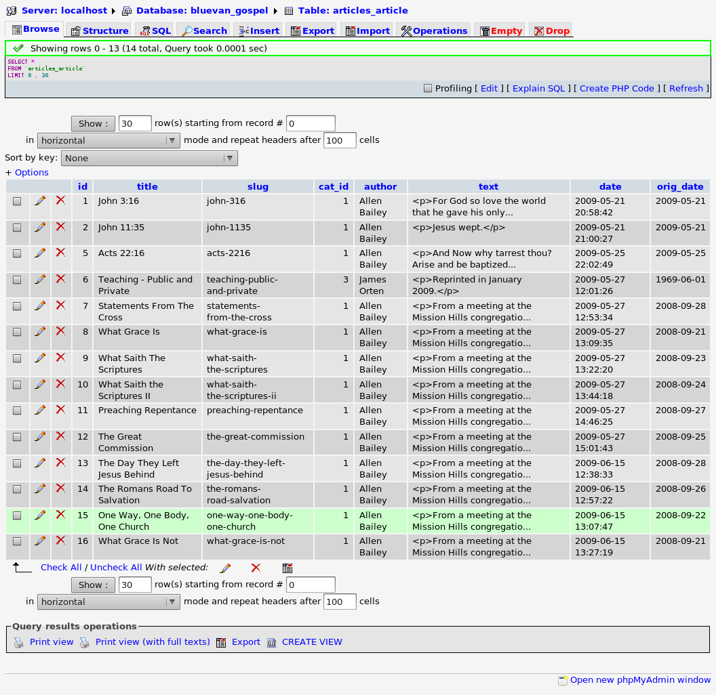
Figure 8 – Implemented Use Case: View Article – Database screenshot

Initial Requirements Assumptions

Key Domain Classes:
- Article
  - Title, rich text, and meta information for an article or presentation. Media items can also be attached to enrich the material.

- Author
  - Author, or presenter who created one or many articles in the system.
- Media
  - Audio, video, PDF documents, etc. that are attached to an article.
- Category
  - Major categories of article types, for classification purposes.
- Tag
  - Metadata attached to an article, indicating keywords and subject matter.
- User (profile information)
  - Social networking account information and simple profile information for the site's social functionality.
- Comment
  - User generated comments in response to an article.
- Like
  - A social indicator showing that a user enjoyed an article.
- Question
  - User submitted question for an administrator to answer and display in a Q&A format.
- Book
  - Published product for sale in the online store.
- Order
  - A customer order for published materials.
- Order Item
  - Line item linking an order with a book and indicating the quantity ordered.

Key Business Functions:
- Add, View, Update, Delete Article
- Add, View, Update, Delete Author
- Attach, Delete Media
- Create, View, Update, Delete Category
- Create, View, Delete Tag
- Add, Remove Tag to/from Article
- Register, View, Update, Delete User
- Add, Delete Comment
- Add, Delete Like
- Ask, View, Update, Delete Question
- Add, View, Update, Delete Book
- Create, View, Update Order
- Add, Update, Delete Order Item

Development Methodology

The project will use an agile approach to the Unified Process for the development methodology. The project will also use an object oriented approach to analysis, design, and implementation. The project will be implemented using the three-layer MVC design architecture typical of the Django framework.

Ultimate Project Disposition

The sponsor will actually use the final system. It will be deployed at the the end of the class as a replacement of the old system. This project came about because Allen is a friend of mine. We've been in discussions for a while about creating a system like the one described here. Allen is very enthusiastic about the project and I will likely continue active development after the initial implementation.

System Benefits

Tangible Benefits

Benefit/Cost Saving | Annual Amount | Comments
Non-technical administrators being able to manage resources themselves. | $3,120.00 | Approximate current maintenance costs that could be done away with: 3 hours/week @ $20/hour
Online publication sales. | $4,250.00 | Preachers' Study CD's: $1,500 + Commentaries: $7,000 = $8,500 annual * 50% estimated increase in sales

Intangible Benefits

- Social interaction, promoting thoughtful discussions on religious subjects.
- Promoting Christianity and edification of members.
- Preservation of religious literary works and multimedia recordings.

Project Schedule and Costs

Phases, Activities, Tasks, and Person Hours

Project Costs

Project Hours | Hourly Rate | Project Development Cost
316 | $20.00 | $6,320.00

Licensing costs will be nonexistent since all the development tools are open source. The operating systems will all be Linux and the server software will be open source as well.

Maintenance Hours / Year | Hourly Rate | Maintenance Cost Annually
120 | $20.00 | $2,400.00

The following five year cost table takes into account the previous two tables on development and maintenance costs, as well as a basic hosting cost of $7.95/month and $10.69/year for a domain name.

 | Year 0 | Year 1 | Year 2 | Year 3 | Year 4 | Year 5
Development Cost | $6,320.00 | $0.00 | $0.00 | $0.00 | $0.00 | $0.00
Maintenance Cost | $0.00 | $2,400.00 | $2,400.00 | $2,400.00 | $2,400.00 | $2,400.00
Hosting Cost | $0.00 | $106.09 | $106.09 | $106.09 | $106.09 | $106.09
Total Costs | $6,320.00 | $2,506.09 | $2,506.09 | $2,506.09 | $2,506.09 | $2,506.09

Feasibility Study

Organizational and Cultural Feasibility
The owner, Allen Bailey, is the principle stakeholder and is very enthusiastic about the project. The only issue I can see arising would be if the system didn't have a simple enough of an interface. Usability was one point that he stressed, but I don't think it will cause any issues.

Evaluating the Technological Feasibility
Security could be an issue since it is a web based system. Appropriate measures will need to be taken to ensure that the system is kept secure. Since Django is a web framework that I'm very familiar with, I don't think there will be any issues on the implementation side.

Determining the Schedule Feasibility
Since the project has a sort time frame of a single semester and I am the only analyst/developer, it will be important to stick to the project management plans and not get side-tracked. However, with due diligence I think the schedule is certainly feasible.

Assessing the Resource Feasibility
The only resources here are my time and the hosting fees once the project goes live. After talking with Allen, resource feasibility seems reasonable as well.

Determining the Economic Feasibility

 | Year 0 | Year 1 | Year 2 | Year 3 | Year 4 | Year 5 | Total
Value of benefits |  | $7,370.00 | $7,370.00 | $7,370.00 | $7,370.00 | $7,370.00
Discount factor (%10) | 1.0000 | 0.9091 | 0.8264 | 0.7513 | 0.6830 | 0.6209
Present value of benefits |  | $6,700.07 | $6,090.57 | $5,537.08 | $5,033.71 | $4,576.03 | $27,937.46
Development costs | ($6,320.00) |  |  |  |  |  | ($6,320.00)
Ongoing costs |  | ($2,506.09) | ($2,506.09) | ($2,506.09) | ($2,506.09) | ($2,506.09)
Discount factor (%10) | 1.0000 | 0.9091 | 0.8264 | 0.7513 | 0.6830 | 0.6209
Present value of costs |  | ($2,278.29) | ($2,071.03) | ($1,882.83) | ($1,711.66) | ($1,556.03) | ($9,499.84)
PV of net of benefits and costs | ($6,320.00) | $4,421.78 | $4,019.54 | $3,654.25 | $3,322.05 | $3,020.00
Cumulative NPV | ($6,320.00) | ($1,898.22) | $2,121.32 | $5,775.57 | $9,097.62 | $12,117.62
Payback Period | 1 Year, 5 Months, 22 Days
5-year ROI | 76.60%

Summary
The economic feasibility alone is very good for this kind of system. No major hurdles to feasibility exist at this time. The favorable feasibility analysis combined with the significant intangible benefits puts the project in good standing.

Project Monitoring/Reporting To Date

Appendix A: Code Excerpts

models.py

from django.db import models
from datetime import date
from tinymce import models as tinymce_models
import os.path
from django.conf import settings

def get_filename(instance, filename):
split = filename.split('.')
ext = ''.join(['.', split[len(split) - 1]])
month = ''.join([str(date.today().year), '_', str(date.today().month)])
slug = instance.parent.slug
t = (None,"audio")[isinstance(instance, Audio)]
t = (t,"video")[isinstance(instance, Video)]
t = (t,"docs")[isinstance(instance, Document)]
t = (t,"other")[isinstance(instance, OtherMedia)]
fn = ''.join(['article/', month, '/', t, '/', slug, ext])
i = 1
if instance.src:
instance.src.delete()
while True:
if os.path.exists(''.join([settings.MEDIA_ROOT, fn])):
fn = ''.join(['article/', month, '/', t, '/', slug, '_', str(i), ext])
else:
return fn

def convert_youtube(url):
sep = url.find('?v=')
if sep > 0:
url = 'http://www.youtube.com/v/%s' % url[sep + 3:]
sep = url.find('&')
if sep > 0:
url = url[:sep]
return url

class Article(models.Model):
title = models.CharField(max_length=200)
slug = models.SlugField()
cat = models.ForeignKey('Category')
author = models.CharField(max_length=200)
text = tinymce_models.HTMLField(blank=True)
date = models.DateTimeField('date published', auto_now_add=True)
orig_date = models.DateField('date originally created')
class Meta:
ordering = ['-date']
def __unicode__(self):
return self.slug

class Audio(models.Model):
parent = models.ForeignKey('Article')
title = models.CharField(max_length=200)
src = models.FileField(upload_to=get_filename, null=True, blank=True)
class Meta:
verbose_name_plural = "audio"
ordering = ['parent','title']
def __unicode__(self):
return ''.join([self.parent.slug, "/", self.title])

class Video(models.Model):
parent = models.ForeignKey('Article')
title = models.CharField(max_length=200)
src = models.FileField(upload_to=get_filename, null=True, blank=True)
class Meta:
ordering = ['parent','title']
def __unicode__(self):
return ''.join([self.parent.slug, "/", self.title])

class YouTube(models.Model):
parent = models.ForeignKey('Article')
title = models.CharField(max_length=200)
url = models.URLField(null=True, blank=True)
class Meta:
verbose_name_plural = "YouTube"
ordering = ['parent','title']
def save(self):
self.url = convert_youtube(self.url)
super(YouTube, self).save()
def __unicode__(self):
return ''.join([self.parent.slug, "/", self.title])

class Document(models.Model):
parent = models.ForeignKey('Article')
title = models.CharField(max_length=200)
src = models.FileField(upload_to=get_filename, null=True, blank=True)
class Meta:
ordering = ['parent','title']
def __unicode__(self):
return ''.join([self.parent.slug, "/", self.title])

class OtherMedia(models.Model):
parent = models.ForeignKey('Article')
title = models.CharField(max_length=200)
src = models.FileField(upload_to=get_filename, null=True, blank=True)
class Meta:
verbose_name_plural = "other media"
ordering = ['parent','title']
def __unicode__(self):
return ''.join([self.parent.slug, "/", self.title])

class Category(models.Model):
title = models.CharField(max_length=200)
slug = models.SlugField()
description = tinymce_models.HTMLField(blank=True)
class Meta:
verbose_name_plural = "categories"
ordering = ['title']
def __unicode__(self):
return self.slug

urls.py

from django.conf.urls.defaults import *

urlpatterns = patterns('',
(r'^$', 'gospel_preaching.articles.views.index'),
(r'^(?P<cat>[a-zA-Z0-9_-]+)/$', 'gospel_preaching.articles.views.cat'),
(r'^(?P<cat>[a-zA-Z0-9_-]+)/(?P<slug>[a-zA-Z0-9_-]+)/$', 'gospel_preaching.articles.views.detail'),
)

views.py

from django.shortcuts import render_to_response, get_object_or_404
from gospel_preaching.articles.models import Article, Category
from django.template import RequestContext
from django.core.paginator import Paginator
from django.conf import settings

def index(request):
order = request.GET.get('order', '-date')
page = request.GET.get('page', 1)
try:
perpage = settings.ARTICLES_PER_PAGE
except AttributeError:
perpage = 10
pager = Paginator(Article.objects.all().order_by(order), perpage)
return render_to_response('articles/index.html', {'all_articles': pager.page(page).object_list, 'order': order, 'page': pager.page(page), 'pager': pager}, context_instance = RequestContext(request))

def detail(request, cat, slug):
a = get_object_or_404(Article, slug__exact=slug)
return render_to_response('articles/detail.html', {'article': a}, context_instance = RequestContext(request))

def cat(request, cat):
order = request.GET.get('order', '-date')
page = request.GET.get('page', 1)
try:
perpage = settings.ARTICLES_PER_PAGE
except AttributeError:
perpage = 10
c = get_object_or_404(Category, slug__exact=cat)
pager = Paginator(c.article_set.all().order_by(order), perpage)
return render_to_response('articles/cat.html', {'cat': c, 'articles': pager.page(page).object_list, 'order': order, 'page': pager.page(page), 'pager': pager}, context_instance = RequestContext(request))

base.html

<!DOCTYPE html PUBLIC "-//W3C//DTD XHTML 1.0 Strict//EN" "http://www.w3.org/TR/xhtml1/DTD/xhtml1-strict.dtd">
<html xmlns="http://www.w3.org/1999/xhtml" xml:lang="en" lang="en">
<head>
<meta http-equiv="Content-Style-Type" content="text/css" />
<title>{% block title %}Gospel Preaching.com{% endblock %}</title>
<link rel="stylesheet" href="{{ MEDIA_URL }}style/content.css" type="text/css" />
<link rel="stylesheet" href="{{ MEDIA_URL }}style/content_low_res.css" type="text/css" id="var_style" />
{% block css %}{% endblock %}
{% block script %}{% endblock %}
</head>

<body>
<div class="main">
{% block main %}{% endblock %}
</div>
{% include "master/side_menu.html" %}
<div class="header_bar">
<h1><a href="/">Gospel Preaching.com</a></h1>
</div>
<a href="/"><img class="logo" src="{{ MEDIA_URL }}logos/simple_logo_150.png"/></a>
<script type="text/javascript">
<!--
if(screen.width > 800){
document.getElementById('var_style').href = '';
}
//-->
</script>
<script type="text/javascript">
<!--
var gaJsHost = (("https:" == document.location.protocol) ? "https://ssl." : "http://www.");
document.write(unescape("%3Cscript src='" + gaJsHost +
"google-analytics.com/ga.js' type='text/javascript'%3E%3C/script%3E"));
//-->
</script>
<script type="text/javascript">
<!--
try {
var pageTracker = _gat._getTracker("UA-9202863-2");
pageTracker._trackPageview();
} catch(err) {}
//-->
</script>
</body>
</html>

index.html

{% extends "base.html" %}
{% load custom %}

{% block css %}
{% endblock %}
{% block script %}
{% endblock %}

{% block main %}
<h2>{{ cur_app.header }}</h2>
{{ cur_app.description|safe }}
{% if all_articles %}
<div class="list_table">
<div class="list_item_odd">
<span class="list_title"><a href="{% orderurl 'title' order %}">Title</a></span>
<span class="list_cat"><a href="{% orderurl 'cat__title' order %}">Category</a></span><br />
<span class="list_author"><a href="{% orderurl 'author' order %}">Author</a></span>
<span class="list_dates_media">
<span class="list_date"><a href="{% orderurl 'date' order %}">Date</a></span>
<span class="list_orig_date"><a href="{% orderurl 'orig_date' order %}">Original Date</a></span>
<span class="list_media">Available Media</span>
</span>
</div>
{% include "helpers/navigation.html" %}
{% for article in all_articles %}
<div class="list_item_{% cycle 'even' 'odd' %}">
<span class="list_title"><a href="{% url gospel_preaching.articles.views.detail article.cat.slug article.slug %}">{{ article.title }}</a></span>
<span class="list_cat"><a href="{% url gospel_preaching.articles.views.cat article.cat.slug %}">{{ article.cat.title }}</a></span><br />
<span class="list_author">{{ article.author }}</span>
<span class="list_dates_media">
<span class="list_date">{{ article.date|date:"m/d/Y" }}</span>
<span class="list_orig_date">{{ article.orig_date|date:"m/d/Y" }}</span>
<span class="list_media">
<img src="{{ MEDIA_URL }}img/text_{{ article.text|striptags|yesno }}.png" />
<img src="{{ MEDIA_URL }}img/audio_{{ article.audio_set.all|yesno }}.png" />
<img src="{{ MEDIA_URL }}img/youtube_{% if article.video_set.all or article.youtube_set.all %}yes{% else %}no{% endif %}.png" />
<img src="{{ MEDIA_URL }}img/doc_{{ article.document_set.all|yesno }}.png" />
<img src="{{ MEDIA_URL }}img/other_{{ article.othermedia_set.all|yesno }}.png" />
</span>
</span>
</div>
{% endfor %}
{% include "helpers/navigation.html" %}
</div>
{% else %}
<p>No articles are available.</p>
{% endif %}
{% endblock %}

detail.html

{% extends "base.html" %}

{% block css %}
<link rel="stylesheet" href="{{ MEDIA_URL }}style/video.css" type="text/css" />
{% endblock %}
{% block script %}
<script type="text/javascript" src="{{ MEDIA_URL }}scripts/audio-player.js"></script>
<script type="text/javascript" src="{{ MEDIA_URL }}scripts/flowplayer-3.1.0.min.js"></script>
<script type="text/javascript" src="{{ MEDIA_URL }}scripts/flowplayer.controls-3.0.2.js"></script>
{% endblock %}

{% block main %}
<h2>{{ article.title }}</h2>
<table class="header_block">
<tr><td>Catagory:</td><td><a href="{% url gospel_preaching.articles.views.cat article.cat.slug %}">{{ article.cat.title }}</a></td></tr>
<tr><td>Date Uploaded:</td><td>{{ article.date|date:"m/d/y" }}</td></tr>
<tr><td>Original Date:</td><td>{{ article.orig_date|date:"m/d/y" }}</td></tr>
<tr><td>Author:</td><td>{{ article.author }}</td></tr>
</table>
{{ article.text|safe }}
{% if article.audio_set.all %}
<div class="content_block">
<h3>Audio</h3>
{% for audio in article.audio_set.all %}
<h5>{{ audio.title }}</h5>
<object id="{{ article.slug }}" height="24" width="290" data="{{ MEDIA_URL }}scripts/player.swf" type="application/x-shockwave-flash">
<param value="{{ MEDIA_URL }}scripts/player.swf" name="movie"/>
<param value="playerID={{ article.slug }}&soundFile={{ MEDIA_URL }}{{ audio.src }}" name="FlashVars"/>
<param value="high" name="quality"/>
<param value="false" name="menu"/>
<param value="transparent" name="wmode"/>
</object><br />
<a href="{{ MEDIA_URL }}{{ audio.src }}">Download</a>
{% endfor %}
</div>
{% endif %}
{% if article.video_set.all or article.youtube_set.all %}
<div class="content_block">
<h3>Video</h3>
{% if article.video_set.all %}
{% for video in article.video_set.all %}
<h5>{{ video.title }}</h5>
<a
href="{{ MEDIA_URL }}{{ video.src }}"
style="display:block;width:425px;height:344px"
id="player{{ video.id }}">
</a>
<!--HTML based control bar: <div id="controls{{ video.id }}" class="video_controls"></div>-->
<script>
<!--
flowplayer("player{{ video.id }}", "{{ MEDIA_URL }}scripts/flowplayer-3.1.0.swf", {
clip: {
autoPlay: false,
autoBuffering: true
},

plugins: {
controls: {
url: '{{ MEDIA_URL }}scripts/flowplayer.controls-3.1.0.swf',
backgroundColor: '#000000',
backgroundGradient: '[0.2, 1.0, 0.6]',
buttonColor: '#707070',
sliderColor: '#707070',
bufferColor: '#A0A0A0',
progressColor: '#FF0000',
buttonOverColor: '#A0A0A0',
volumeSliderColor: '#707070',
timeBgColor: '#707070',
timeColor: '#FF1010',
tooltipColor: '#707070'
}
}

});
//-->
</script>
<a href="{{ MEDIA_URL }}{{ video.src }}">Download</a>
{% endfor %}
{% endif %}
{% if article.youtube_set.all %}
<h4>YouTube</h4>
{% for youtube in article.youtube_set.all %}
<h5>{{ youtube.title }}</h5>
<object width="425" height="344" style="display:block;">
<param name="movie" value="{{ youtube.url }}&hl=en&fs=1&rel=0"></param>
<param name="allowFullScreen" value="true"></param>
<param name="allowscriptaccess" value="always"></param>
<embed src="{{ youtube.url }}&hl=en&fs=1&rel=0" type="application/x-shockwave-flash" allowscriptaccess="always" allowfullscreen="true" width="425" height="344"></embed>
</object>
{% endfor %}
{% endif %}
</div>
{% endif %}
{% if article.document_set.all %}
<div class="content_block">
<h3>Document</h3>
{% for doc in article.document_set.all %}
<h5>{{ doc.title }}</h5>
<a href="{{ MEDIA_URL }}{{ doc.src }}">Download</a>
{% endfor %}
</div>
{% endif %}
{% if article.othermedia_set.all %}
<div class="content_block">
<h3>Other Media</h3>
{% for media in article.othermedia_set.all %}
<h5>{{ media.title }}</h5>
<a href="{{ MEDIA_URL }}{{ media.src }}">Download</a>
{% endfor %}
</div>
{% endif %}
{% endblock %}

Legal Notes

This work by David Nichols is licensed under a Creative Commons Attribution-Noncommercial-Share Alike 3.0 United States License. To view a copy of this license, visit <http://creativecommons.org/licenses/by-nc-sa/3.0/us/>. Some rights reserved.

GospelPreaching.com and the associated globe logo are Copyright © 2009 by Contending for the Faith Publications. All rights reserved.



The code included herein is Copyright © 2010 by David Nichols.

The code files included in this documentation are part of GospelPreaching.com.

GospelPreaching.com is free software: you can redistribute it and/or modify it under the terms of the GNU General Public License as published by the Free Software Foundation, either version 3 of the License, or (at your option) any later version.

GospelPreaching.com is distributed in the hope that it will be useful, but WITHOUT ANY WARRANTY; without even the implied warranty of MERCHANTABILITY or FITNESS FOR A PARTICULAR PURPOSE. See the GNU General Public License for more details.

Please see <http://www.gnu.org/licenses/gpl.html> for a copy of the GNU General Public License.

Other Notes
I want to give credit to the amazing Django web framework and thank the amazing people that work on it. “It lets you build high-performing, elegant Web applications quickly.” Please check out the Django project's site: <http://www.djangoproject.com/>


